**M1 – Explain persistence of vision**

**Introduction**

In this report, I will explain the persistence of vision used in animation.

**Persistence of vision**

Persistence of vision is a theory used upon human being’s vision. POF means the human eye has an illusion for the image being persisting. This ability only lasts for a second after it has been removed. Therefore, it links with animation by every two frames being shown as one picture. The theory is that when we cannot see each frame of the image. An example is shown below. If the penny was shaken, we would not be able to see each frame. This would link to animation by the illusion being 4 frames shaken of the penny. It would use persistence of vision by showing us 2 frames only.

[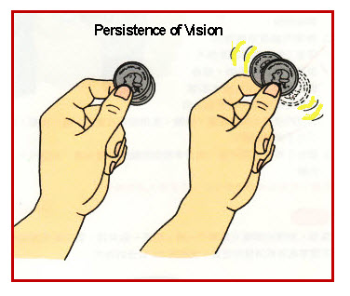](https://www.google.co.uk/url?sa=i&rct=j&q=&esrc=s&source=images&cd=&cad=rja&uact=8&ved=0CAcQjRw&url=https://caworld3.wordpress.com/tag/persistence-of-vision/&ei=jvJBVcncEcuAU5r9gKgB&bvm=bv.92189499,d.d2s&psig=AFQjCNFbAMhSZfEl-_ch5ucc4kAotTlWFA&ust=1430471655624875)

**Some animations rely on persistence of vision. Some of these include:**

**1. Praxinoscope**

**2. Zeotrape**

[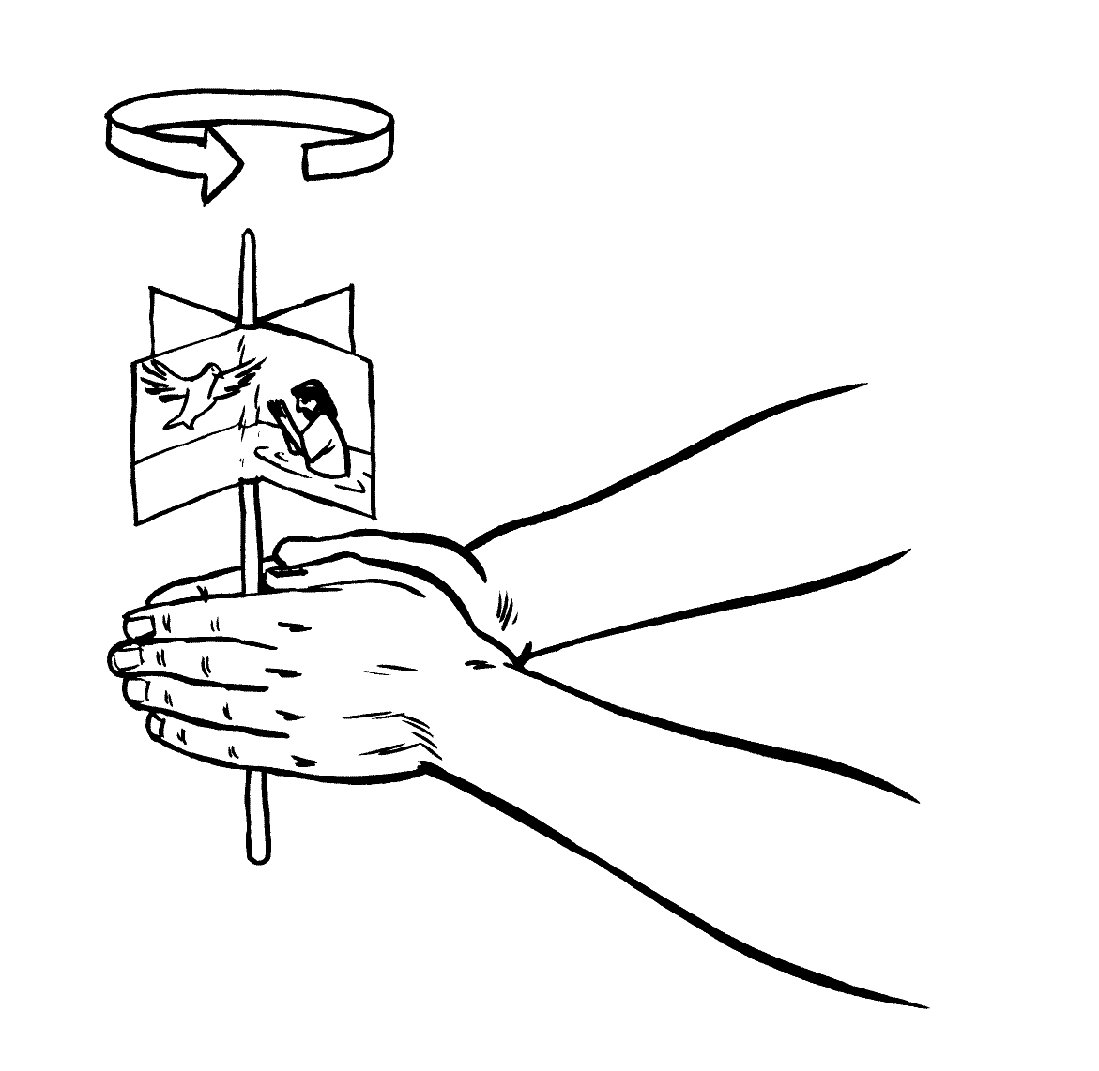](http://www.google.co.uk/url?sa=i&rct=j&q=&esrc=s&source=images&cd=&cad=rja&uact=8&ved=0CAcQjRw&url=http://www.cacourses.com/AN35S/history.html&ei=4PZBVY72GIziapKKgIgO&bvm=bv.92189499,d.d2s&psig=AFQjCNFLK55fmWYKm1NsrHbKPG9ycan83g&ust=1430472795668963)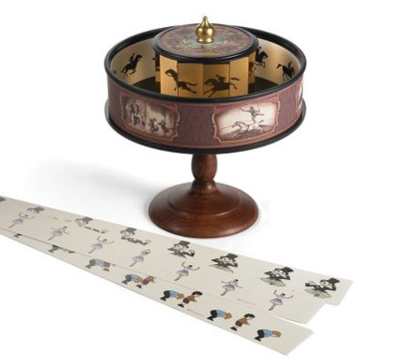**3. Thaumatrope**

2.

[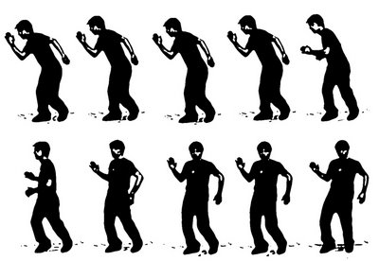](http://www.google.co.uk/url?sa=i&rct=j&q=&esrc=s&source=images&cd=&cad=rja&uact=8&ved=0CAcQjRw&url=http://www.freezeframeonline.org/optical-illusions-and-the-magic-of-moving-pictures/&ei=VfZBVYPTHobgase6gKgM&bvm=bv.92189499,d.d2s&psig=AFQjCNFXWbgxSP7APIP0_qHk0UG84LkH3g&ust=1430472649404517)

3.

1.